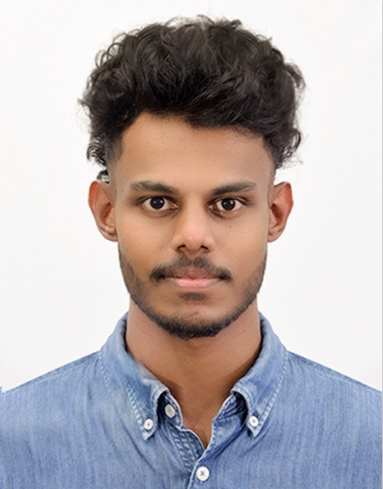 |  | Kusal Ranasinghe

Contact

- Kusal D Ranasinghe
- LinkedIn – Kusal Ranasinghe
- Dananjayakusal39@gmail.com
- 078 799 6831
- “Kusum Sewana” Kajuduwawatta,
Dodangoda

Skills

- Time management
- Communication
- Team work
- Management

LANGUAGES

- Sinhala (Fluent)
- English (Good)

personal profile

- Full Name : Uduwarage Kusal Dhananjaya Ranasinghe
- Date of Birth : 13/11/2003
- NIC : 200331811106
- Gender : Male
- Age : 21
- Schools attended : K/Gnanodaya National School
( Grade 01-06 )
Ananda Sastralaya National School ( Grade 06-13 )

education

- Bachelor of Science Degree ( Computer Science, Mathematics, Physics )
University of Sri Jayawardenapura

- G.C.E Advanced Level Examination | 2023
Physical Science Stream – Passed , District Rank : 363
Chemistry – B
Physics – C
Combined Mathematics – C

- G.C.E Ordinary Level Examination | 2019
Passed with 2 “A”, 6 “B”, 1 “C” Passes
Mathematics – A
English – B

- Diploma in Information Technology
IMBS Green Campus

- Diploma in English ( Level 2 )
Aquinas Collage of Higher Studies

- Certification Course in Python Programming
University of Moratuwa
https://open.uom.lk/verify
Verification Code: EQ32gGqVFQ

- Certification Course in Web Development
University of Moratuwa

- Certification Course in Information Technology
IBS Campus – International Business Studies Campus

- Certification Course in English Language
IBS Campus – International Business Studies Campus

- Certification Course in Business Management & Marketing
IBS Campus – International Business Studies Campus

- Certification Course in Human Resources Management
IBS Campus – International Business Studies Campus

Extra-Curricular Qualification
hh

